Table of Contents

[1. INSTALLATION 2](#_Toc196229393)

[1.1 System Requirements 2](#_Toc196229394)

[1.2 Installation Instructions 2](#_Toc196229395)

[2. Image Analysis Workflow 2](#_Toc196229396)

[2.1 Segmentation 3](#_Toc196229397)

[2.2 Fibre Detection 4](#_Toc196229398)

[2.3 Gap Analysis 5](#_Toc196229399)

[2.4 Batch Processing 6](#_Toc196229400)

[2.5 Cabana Outputs 7](#_Toc196229401)

[3. PARAMETER DETAILS 9](#_Toc196229402)

[3.1 Configurations 9](#_Toc196229403)

[3.2 Segmentation Parameters 9](#_Toc196229404)

[3.3 Fibre Detection and Quantification 10](#_Toc196229405)

[Detection 10](#_Toc196229406)

[Quantification 11](#_Toc196229407)

[3.4 Gap Analysis Parameters 12](#_Toc196229408)

[4. List of Cabana Read-outs (QuantificationResults.csv) 12](#_Toc196229409)

[4.1 Statistics Interpretation and Calculations 12](#_Toc196229410)

[4.2 Gap Analysis Results 14](#_Toc196229411)

[5. FAQs 15](#_Toc196229412)

**CABANA (C**OLL**A**GEN FI**B**RE **ANA**LYZER)

This program was developed for analysing collagen fibre architecture in IHC and fluorescence microscopy images. It provides a user-friendly interface for optimizing analysis parameters and batch processing of collagen fibre images. Additionally, it can be imported as a python library for automated or customised analysis workflows.

For questions, please contact Xufeng Lin ([x.lin@garvan.org.au](mailto:x.lin@garvan.org.au)) or Astrid Magenau ([a.magenau@garvan.org.au](mailto:a.magenau@garvan.org.au)).

# INSTALLATION

## 1.1 SystemRequirements

## 1.2 Installation Instructions

1. Install [miniconda](https://docs.anaconda.com/miniconda/install/" \l "quick-command-line-install). The default installation location is “C:\ProgramData\miniconda3” on Windows. Verify the installation by running “conda env list” in the command line. If the installation was successful, you should be able to see a ‘base’ env and the path to the env.
2. Create a conda env named “cabana” (you can change it to any name you want) by running “conda create -n cabana python=3.10” in the command line. If the env is created correctly, activate the created conda env by running “conda activate cabana”.
3. Install Cabana by running “pip install -U cabana”. If the installation is successful, you can start Cabana GUI by running “python -m cabana”. Alternatively, you can import Cabana in your code for more customised analysis (see examples in tutorial.ipynb).

If you want to create a shortcut on Desktop, follow the steps below:

1. Make sure that Git is installed. If not, download it from this [link](https://git-scm.com/download/win" \t "_blank) and install it. Verify the installation by running "git --version" in the command line.
2. Run "git clone <https://github.com/lxfhfut/Cabana.git>" in the command line. You will be prompted to log in using your GitHub account. If authentication is successful, a "Cabana" folder will be downloaded to your current working directory. You can move (copy-and-paste) the folder to any installation location and change the current working direction to “Cabana” folder.
3. Modify the content in cabana.bat. Make sure CONDAPATH is set to the folder where miniconda was installed, ENVNAME is set to “cabana” and the command on line 19 is set to “python -m cabana”.
4. Create a "Cabana" shortcut on "C:\Users\Public\Desktop" for cabana.bat. Change the icon of Cabana to any icon you want, or you can use the ‘cabana-logo.ico’ in the downloaded ‘Cabana’ folder from Github. You are now ready to use Cabana by double clicking the shortcut.

# Image Analysis Workflow

Once the Cabana GUI is launched, you’ll see a window split horizontally: the control panel on the left and the image viewing area on the right. The program is designed to let you:

1. experiment with parameters for different components using your data, and
2. export the optimized parameters for batch processing on larger datasets.

To begin, select a representative image from your dataset, then sequentially work through the parameter sections for image segmentation, fiber detection, and gap analysis to determine the optimal settings for your analysis.

## 2.1 Segmentation

Under the ‘**Segmentation**’ tab, you will find the parameters for adjusting the segmentation:

1. **Colour of Interest**: Specifies the primary colour used for selecting areas of interest in the segmentation. You can choose this colour directly from the image using the colour selector.
2. **Normalised Hue**: Sets the hue value (in the range [0, 1]) in the HSB/HSV colour space corresponding to the selected segmentation colour.
3. **Colour Threshold**: Defines the minimum mean hue value required for a segment to be considered part of the region of interest (ROI).
4. **Number of Labels**: Controls the level of granularity in the segmentation by specifying the number of distinct labels.
5. **Max Number of Iterations**: Sets the maximum number of iterations to run during the segmentation process.
6. **White Background**: Determines whether the non-ROI areas are filled with white. Enabled by default. Disable this option if you're detecting bright fibres on a dark background.

Note: if you want to select a different colour of interest on the image, you can use the button “**Reload Image**” to reload image so that the original image will be shown again on the image viewer.

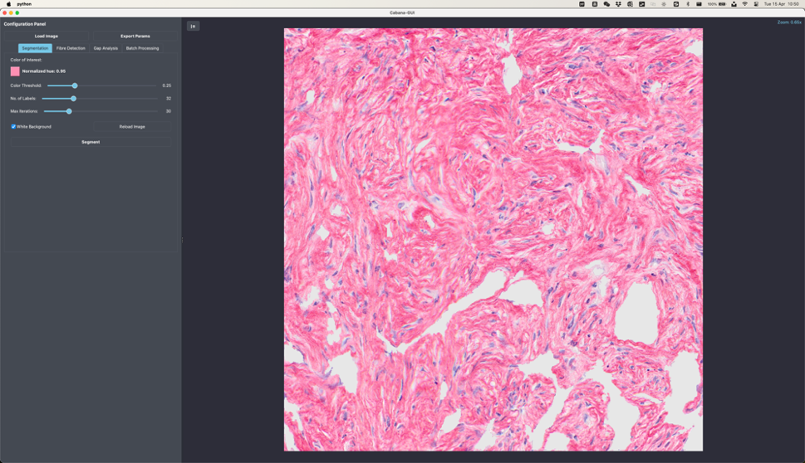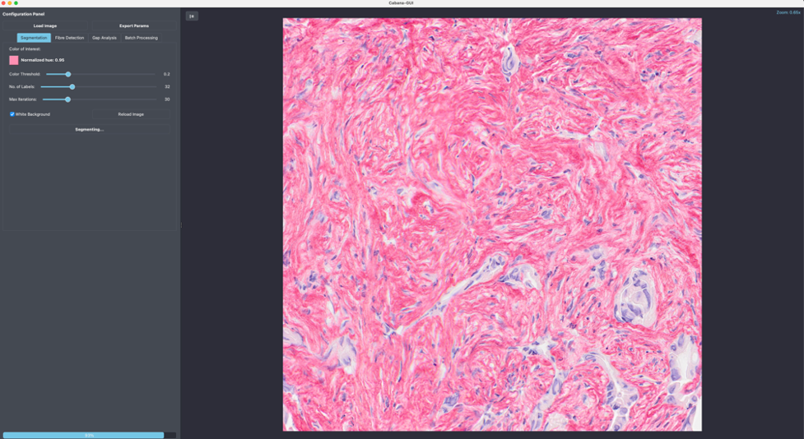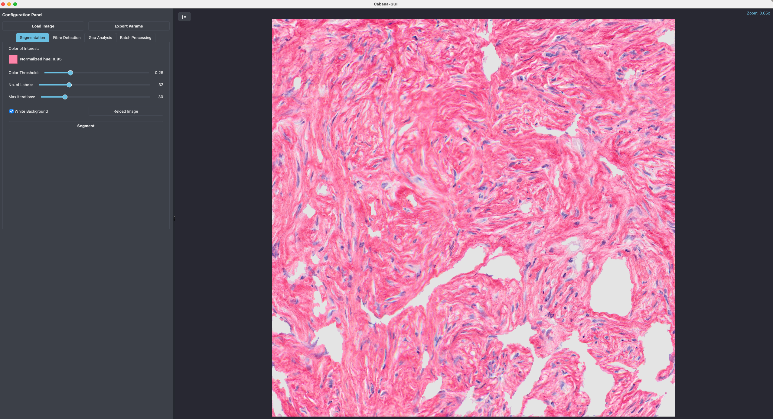

5

4

2

1

3

## 2.2 Fibre Detection

The ‘**Detection**’ tab defines the fibre detections parameters as described below:

1. **Line Width (px)**: Specifies the minimum and maximum width (in pixels) of lines (ridges) to be detected by the ridge detection algorithm.
2. **Line Step (px)**: Sets the sampling interval for line widths between the defined minimum and maximum values.
3. **Contrast**: Defines the lower and upper grayscale contrast thresholds between fibres (lines) and the background.
4. **Minimum Line Length (px)**: Sets the minimum allowable length (in pixels) for detected fibres. Lines shorter than this value will be ignored.
5. **Dark Line**: Enables detection of dark fibres on a light background (e.g., Picrosirius Red-stained images). Disable this option when detecting light fibres on a dark background (e.g., fluorescent or SHG images).
6. **Extend Line**: Enables fibre detection near junctions. Note that it may result in fibre artefacts and should be used with caution.

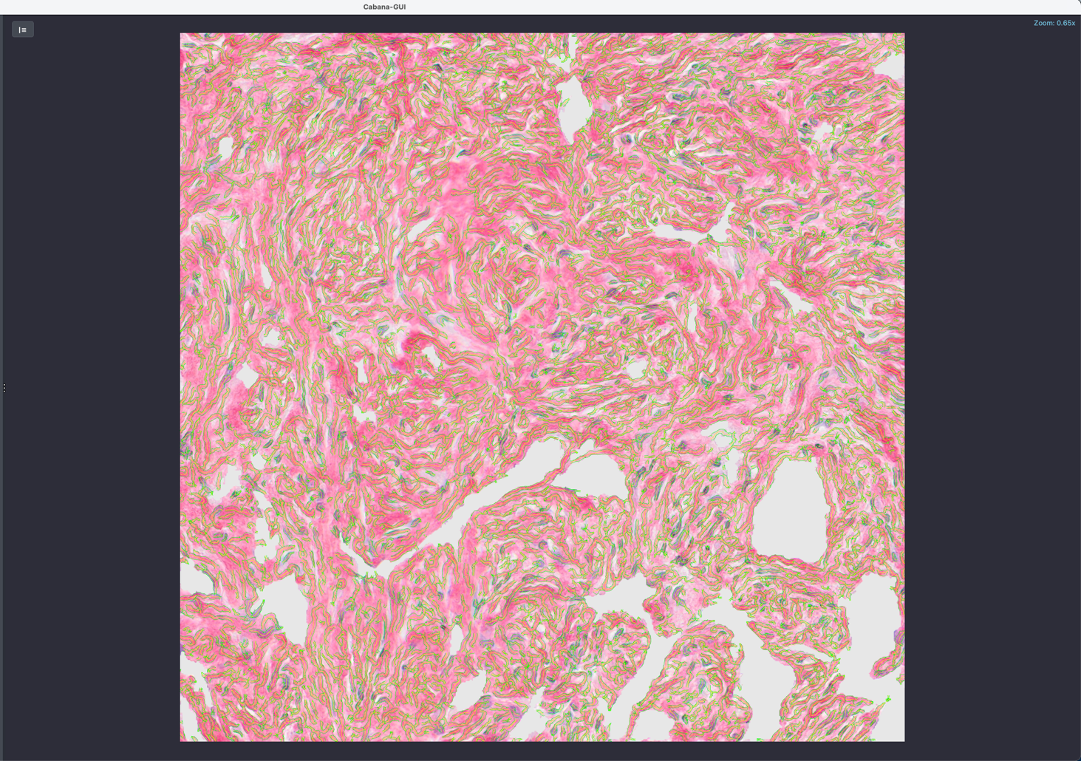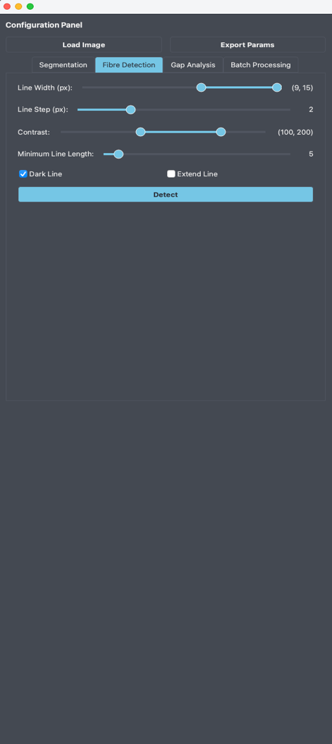

3

4

2

1

## 2.3 Gap Analysis

The ‘**Gap Analysis**’ tab defines the parameters for gap analysis as described below:

1. **Minimum gap diameter**: the minimum diameter of detected gaps (pixels).
2. **Max Display HDM:** the maximum intensity value of the high-density matrix.

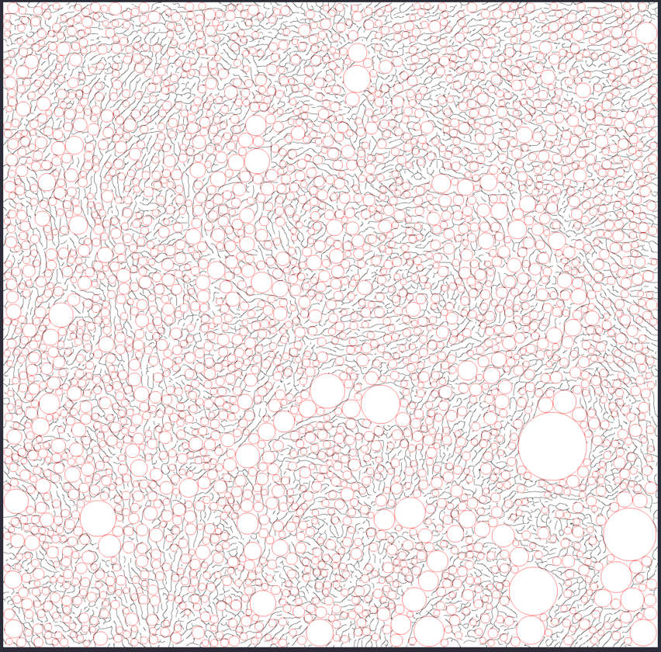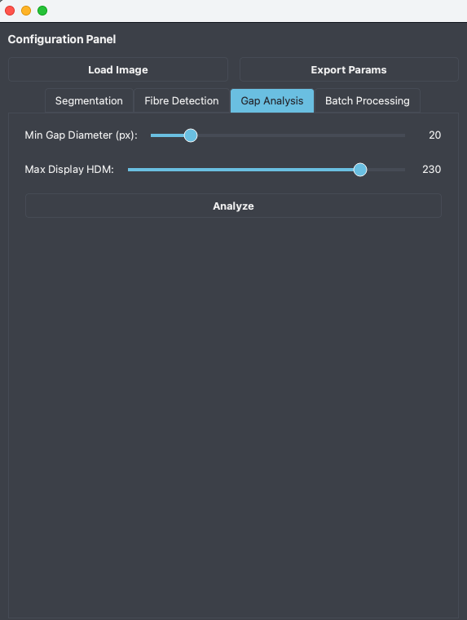

4

3

2

1

Once all parameters in ‘Segmentation’, ‘Detection’ and ‘Gap Analysis’ have been selected, the user can export the selected parameters to a parameter configuration yml file, say Parameters.yml, which can then be used for batch processing.

## 2.4 Batch Processing

Under the ‘**Batch Processing**’ tab, the user can specify the parameter file, input folder containing the images to be quantified, and the output folder for storing the results. It is recommended to open the Parameters.yml file to review and adjust the settings as needed—for example, disabling segmentation/gap analysis or adjusting specific parameters (refer to the parameter details in next section). Cabana will process the images in the input folder in batches (default batch size is 5). If an issue causes the program to terminate, the user can resume processing from the last batch after addressing the problem.

**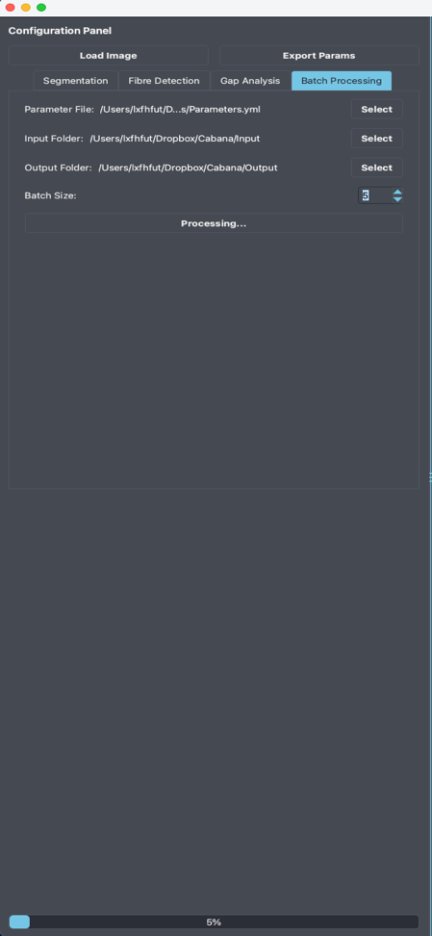 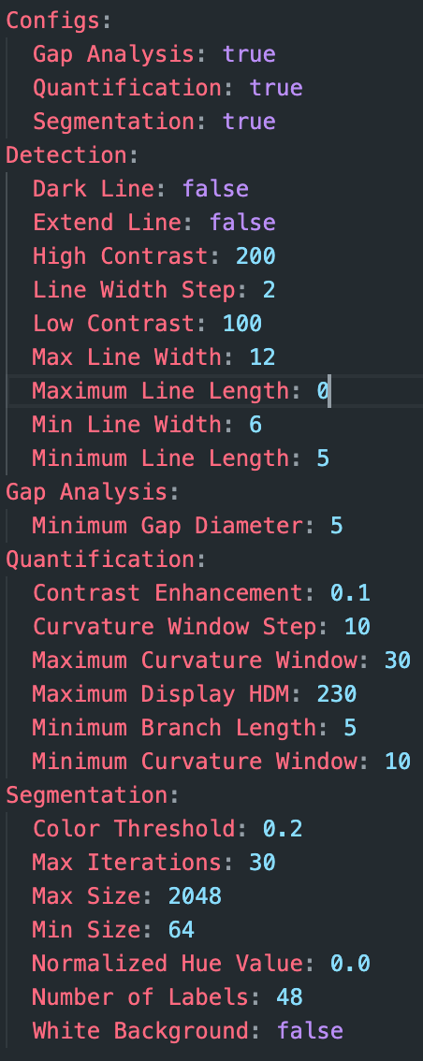**

3

2

1

## 2.5 Cabana Outputs

Cabana generates an output folder containing the following subfolders:

1. **Batches**

Stores the results of each analysis batch. Cabana processes images in batches to allow the use of a check-point in case the analysis run crashes and needs to be restarted (see below under ‘errors’). The results of all batches are combined into the folders below. Note: Batches folder can be safely deleted when all images have been processed to save storage space.

1. **Bins**

Stores the binary masks resulting from ROI extraction. The ROI regions are highlighted in white while backgrounds are highlighted in black.

1. **Colors**

Stores subfolders of each processed image with the images of the following analysis results:

1. all\_gaps: gap analysis of whole tissue
2. angular\_hist: angular distribution of fibre orientations.
3. color\_coherency: orientation coherency/alignment in a local window =2 for OrientationJ plugin) of the original image. The rule of thumb for the filter size is to be about 3 times the standard deviation (sigma value) in each direction, i.e. window size ~6\*2=12px.
4. colour\_curve: vector field visualization of orientation, with vector lengths weighted by coherency.
5. colour\_energy: vector field visualization of orientation, with vector lengths weighted by energy, i.e., gradient vector magnitude.
6. colour\_length: detected ridges are colour-coded according to fibre length. Note: this only applies to fibres without branches.
7. colour\_mask: detected ridges and branches
8. colour\_orientation: fibre orientation in [] within a local window
9. colour\_skeleton: detected fibres with branchpoints (yellow) and endpoints (green)
10. colour\_width: detected ridges with calculated fibre widths
11. gray\_width: widths in terms of integer pixel numbers at ridge points/pixels.
12. intra\_gaps: gap analysis of intra-collagen fibre gaps
13. orient\_colour\_survey: color coding of orientation in HSB colour space, where hue is orientation, saturation is coherency, brightness is the grayscale of the original image.

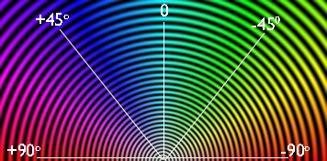

[Circular color map coding for orientation](https://bigwww.epfl.ch/demo/orientationj/)

1. orient\_vf\_constant: vector field visualization of orientation with constant/equal weights
2. **Eligible**

Stores the images to be analysed after the removal over-sized images. The 'Ignored\_images.txt' file inside the subfolder records the names of the over-sized images that have been ignored.

Note: images that are larger than 2048 x 2048 pixels will automatically be cropped into subregions < 2048 x 2048 px and saved as individual ROIs.

1. **Exports**

Contains colour-code images of following results:

1. Coherency: coherency/alignment of orientation in a local neighbourhood
2. Colour survey: same as above in 3.m
3. Curve map: curvatures of the detected fibres for selected curvature window sizes
4. Energy: magnitude of gradient vector (
5. GapImage: Map of tissue gaps (red) – based on non-segmented image
6. GapImage\_intra\_gaps: Map of intra-fibre gaps (green) – based on segmentation ROI
7. Length map: higher intensity values represent longer fibres. The image intensities are stored as unsigned 16-bit integers. Best viewed in ImageJ/FIJI.
8. Mask: detected fibres and fibre branches
9. Orientation: orientation angles in radians ranging from to.
10. Skeleton: shows branchpoints (yellow circles) and endpoints (red circles) of detected fibre spines
11. Width: ridge detection results with the estimated ridge width
12. **HDM**

Stores the high-density matrix areas as defined in Parameters.yml

1. **Masks**

Stores the results of ridge detection and of the gap analysis in the 'GapAnalysis' folder. The ‘GapAnalysis’ folder comprises of two output images for each image. One image features red circles, visualizing the gaps between fibres of the non-segmented image.

The second image shows green circles depicting gaps within collagen fibre areas (intra-collagen gaps) of the segmented image.

1. **Fibres**

Stores the visualization results of ridge detection as an overlay with the original image.

1. **ROIs**

Stores the results of the image segmentation.

1. **QuantificationResults.csv**

Contains all resultant image statistics. Please refer to the section ‘List of Cabana read-outs’ for a detailed explanation of analysis results.

‘Output’ also contains the file version\_params.yaml showing all parameters used for the analysis run and the version of Cabana for version tracking and reproducibility purposes.

# PARAMETER DETAILS

## 3.1 uration

The user in the ‘Configs’ section. For instance, if the background is clean, segmentation may not be needed and therefore can be disabled.

## 3.2 Segmentation Parameters

This component of Cabana aims to extract collagen fibre areas determined by Picrosirius Red staining or SHG in an image from cluttered background based on colour and other low-level features. It relies on a self-supervised semantic segmentation model based on convolutional neural networks to group semantically similar neighbouring pixels. The mean colour of the pixels in the same segment will be compared with a user-specified threshold to determine whether the segment is the region of interest (ROI). The following image segmentation parameters for ROI extraction can be adjusted:

1. **Number of Labels**

The number of labels for semantic segmentation. It controls the level of granularity of segmentation. A higher number of labels will result in segments of smaller size. The default value is 32.

1. **Max Iterations**

The maximal number of iterations for semantic segmentation. This value should be large enough to generate reliable segmentation results but not too high to avoid grouping all pixels into a single segment. The default value is 30.

1. **Normalized Hue Value**

The normalized hue value in [0,1] for the colour of interest in HSB/HSV colour space. The typical hue values for green, blue, and red colour are 0.33, 0.66, and 1.0, respectively.

1. **Colour Threshold**

Colour threshold used to determine ROI. Only segments with a mean colour greater than this threshold will be extracted as ROI. The default value is 0.25.

1. **Min Size**

The minimal size of segments. Any segment with a size smaller than this parameter will be ignored. The default value is 64.

1. **Max Size**

The maximum allowable image size. Any image with a size larger than the \*square\* of this parameter will be ignored by the program. The default value is 2048.

Note:

The program automatically detects whether the image is grayscale or in colour. If it's grayscale, it'll disregard the normalized hue value parameter and solely rely on the colour threshold for segmentation. To extract ROIs of colour images, you may need to adjust the Normalized Hue Value under the “Segmentation” tab or directly modify the “Segmentation” section in the exported “Parameters.yml” to optimise the parameters for your image**.** To segment SHG images, it is recommended to increase the number of iterations from the default value 30 to 50. This needs to be tested and optimised by the user.

When the boundaries between regions of interest (SHG signal or Picrosirius Red areas) and background are not clearly distinguishable, obtaining satisfactory segmentation results can be difficult. To address this, the "**Number of Labels**" and "**Max Iterations**" parameters can be optimised. Increasing the number of labels generally leads to finer granularity in segmentations, which may result in a better segmentation result. Avoid increasing the number of labels beyond 64, otherwise GPU Memory might overflow. On the other hand, decreasing the max iterations may result in premature segmentation, reducing the likelihood of mixing fibres and background. Adjusting the HUE parameter may not have much of an effect as the colour of Picrosirius stained collagen fibres is already red/pink.

## 3.3 Fibre Detection and Quantification

This component is designed to detect and quantify fibre structures in images. The file Parameters.yml contains three dedicated sections for controlling the outcomes of collagen fibre analysis:

1. **Detection**: Parameters for detecting fibres.
2. **Quantification**: Parameters for quantifying fibres.

### Detection

1. **Dark Line**

Set to false = the program assumes that fibres are light on a dark background (fluorescence, birefringence, SHG etc).

Set to true = Dark fibres on a light background (Picrosirius Red IHC).

1. **Min Line Width $ω_{min}$**

It defines the minimum line (ridge) width in pixels that the ridge detection algorithm can detect. The line width $ω$ is used to estimate the 'Sigma' $σ$ parameter of Gaussian filtering kernel: $σ=\frac{ω}{2\sqrt{3}}+0.5$.

1. **Max Line Width $ω_{max}$**

The maximum line (ridge) width in pixels that the ridge detection algorithm can detect.

Twombli runs ridge detection repeatedly with every value between the minimum and maximum line width and calculates the combination of the detected ridges.

Note:

Setting a large line width (e.g., >15) gives rise to the chance of 'straight line artefacts', which are caused by the small (close to zero) upper threshold of filtering response.

1. **Line Width Step**

This parameter controls the sampling factor for line widths between the minimum and the maximum line widths. It allows for increasing the line width by step larger than 1.

For instance, if you want to detect ridges with multiple line widths 5, 7, and 9, you can specify a line width step to 2 with the min line width $ω_{min}=5$ and the max line width $ω_{max}=9$. The default value is 2.

1. **Low Contrast $b_{l}$**

Defines the lowest grayscale contrast between a line (collagen fibre) and background (non-fibre area). This parameter is used to estimate the lower threshold for the filtering response: $T_{L}=\frac{0.17ωb_{l}}{\sqrt{2π}σ^{3}}e^{-\frac{ω^{2}}{8σ^{2}}}.$ Line points with a filtering response lower than the low contrast threshold $T_{L}$ are discarded.

1. **High Contrast $b_{u}$**

The highest grayscale contrast between a line (collagen fibre) and background (non-fibre area). This parameter is used to estimate the upper threshold for filtering response: $T_{U}=\frac{0.17ωb_{u}}{\sqrt{2π}σ^{3}}e^{-\frac{ω^{2}}{8σ^{2}}}$. Line points with a response larger than the high contrast threshold $T_{U}$ are accepted. Line points with a response in [ $T_{L}, T_{U}]$ are added to the accepted line points if line structures are reasonably formed.

Note:

Not the absolute intensity is important, but the difference/contrast of a pixel with its neighbours. This applies to low and high contrast. If a pixel with an intensity of 230 appears among neighbouring pixels with intensity of 230, the filtering response will be zero because this point is not visually salient. If this pixel appears among pixels with an intensity of 10, then the filtering response will be strong enough to signify it as a salient line/ridge point. For example, pixels values > 200 might or might not be accepted depending on their filtering responses. But the higher the contrast threshold, the criteria for a pixel becoming a line point becomes more stringent, therefore less line points will be detected. Also note that, if the ‘Dark Line’ is set to 1 (for Picrosirius Red), the low contrast and high contrast will be calculated as $255-b_{u}$ and $255-b_{l}$, respectively.

### Quantification

1. **Contrast Enhancement**

A value between [0,1] shows the percent of pixels that will be saturated for contrast enhancement.

1. **Min/Max Curvature Window and Curvature Window Step**

The curvature of ridges/lines in curvature windows bounded by the minimum and maximum curvature windows with a window step size.

1. **Minimum Branch Length**

Any line/ridge with a length smaller than this value is ignored.

Note: If the minimum branch length value is too low, short branch artefacts are introduced.

1. **Maximum Display HDM**

Pixels not in [0, maxDisHDM] is set to 0 for estimating high-density matrix (HDM) area.

## 3.4 Gap Analysis Parameters

1. **Minimum Gap Diameter**

The minimal gap diameter for gap analysis.









# 4. List of Cabana Read-outs (QuantificationResults.csv)

Values referring to *WIDTH*, *ROI* and *HDM* are based on the following outputs:

* WIDTH: Values based on ridge detection (found in images named `\*\_Width.png` within the “Exports” folder).
* ROI: Values based on segmented images (located in the “ROI” folder).
* HDM: Values derived from the High-Density Matrix (HDM), represented as non-black areas/pixels in images from the “HDM” folder.

## 4.1 Statistics Interpretation and Calculations

|  |  |  |
| --- | --- | --- |
| Result | Meaning | Calculation Method |
| Total Image Area (µm²) | Total image area in microns² | Total number of pixels × (Image Resolution (µm/pp)) 2 |
| Fibre Area (HDM, µm²) | Projected area of detected ridge spines, typically one pixel wide. | Number of HDM pixels × (Image Resolution (µm/pp)) 2 |
| % HDM Area | Percentage of the image area covered by HDM. | High-density matrix areas are obtained using the following three steps:   1. Set pixels outside the range [0, maxDisHDM] to 0, where maxDisHDMis the value of “Maximum Display HDM” parameter specified in Parameters.yml 2. Apply contrast enhancement to the resultant image using the “Contrast Saturation” parameter specified in Parameters.yml. 3. Calculate % HDM as the portion of pixels in HDM area (% total area), where HDM areas are defined by the non-black pixels in the contrast enhanced image. |
| Avg Thickness (HDM, µm) | Average fibre thickness based on HDM. | HDM area / Total fibre length |
| Mean Fibre Intensity (HDM) | Mean intensity of red (PicrosiriusRed) or gray (SHG) pixels in HDM. | Measured in HDM area. |
| Fibre Area (ROI, µm²) | Area within the segmented ROI. | ROI pixel count × (Image Resolution (µm/pp)) 2 |
| % ROI Area | ROI area as a percentage of the total image area. | ROI area / Total area |
| Avg Thickness (ROI, µm) | Average fibre thickness based on the ROI. | ROI area / Total fibre length |
| Fibre Area (WIDTH, µm²) | Fibre area calculated using ridge detection. | Ridge-detected pixel count × (Image Resolution (µm/pp))2 |
| % Width Area | Fibre coverage based on ridge detection. | WIDTH area / Total area |
| Fibre Coverage (WIDTH/ROI) | Fibre coverage in ROI based on ridge detection. | WIDTH area / ROI area |
| Avg Thickness (WIDTH, µm) | Average fibre thickness using ridge detection. | WIDTH area / Total fibre length |
| Lacunarity | Measure of gaps in the matrix. Larger values indicate larger gaps. | Calculated as , where *s* and $μ$ are the standard deviation and mean of the entire binary ridge image, respectively. |
| Normalized Lacunarity | Lacunarity normalized to total image area (value in [0, 1]). | (Lacunarity - 1) / ((1/area ratio) - 1), where area ratio is the ratio of the number of ridge pixels to the total number of pixels. Refer to <https://sci-hub.mksa.top/10.1016/j.jsg.2010.08.010> for more detail. |
| Total Length (µm) | Total length of fibres derived from ridge detection. | Total fibre length in µm. Pruned ridges (removing artifacts) used to calculate length in microns. |
| Avg Length (µm) | Average fibre length. | Total fibre length / Number of (endpoints + branchpoints) |
| Endpoints | Number of fibre endpoints. | Count of endpoints in ridge detection. |
| Endpoint Density (1/µm) | Endpoint count normalized to fibre length. | Number of endpoints / Total fibre length (µm) |
| Branchpoints | Number of fibre branchpoints. | Count of branchpoints in detected ridges. |
| Branchpoint Density (1/µm) | Branchpoint count normalized to fibre length. | Number of branchpoints / Total fibre length (µm) |
| Box-Counting Fractal Dimension | Indicator of structural complexity. Values in [1, 2] | It is an indicator for the capability of filling space. A more complex structure has a higher tendency to fill up the whole space, thus a higher fractal dimension.  The space filling tendency is measured as the slope of a linear fit to points represented as $(log(1/ϵ_{i}), log(N(ϵ_{i}))$ where $ϵ_{i}$ is the box size, and $N(ϵ_{i})$ represents the count of boxes containing the structure (i.e. ridges). Typically, $ϵ_{i}$ spans from 2 to one-quarter of the image's largest dimension. Refer to <https://imagej.nih.gov/ij/plugins/fraclac/FLHelp/BoxCounting.htm> for more information. |
| Curvature | Mean angle change across a user-defined window size. | Example: Curvature\_20 refers to curvature within a 20px sliding window. |
| Orient. Alignment | Coherency of fibre orientation across the entire image. | Orientation coherency is calculated as ${(λ}_{max}-λ_{min}) / (λ_{max}+λ_{min})$ where $λ_{min}$ and $λ_{max}$ are respectively the largest eigenvalue (major axis) and smallest eigenvalue (minor axis) of the global gradient structure tensor. Refer to the [source code](https://github.com/Biomedical-Imaging-Group/OrientationJ/blob/master/src/main/java/OrientationJ_Dominant_Direction.java#L102) for more info. |
| Orient. Variance | Spread of fibre orientations (circular variation). | Using scipy.stats.circvar on blockwise orientations. |

## 4.2 Gap Analysis Results

|  |  |  |
| --- | --- | --- |
| Result | Meaning | Calculation Method |
| Mean (All gaps area in µm2) | Mean Max Inscribed Circle area in entire image | Refer to [here](https://imagej.net/plugins/max-inscribed-circles) for more info about Max Inscribed Circles. |
| Normalized Mean (All gaps area) | Mean area of Max Inscribed Circle normalised to total image area |  |
| Std (All gaps area in µm2) | StDev of Max Inscribed Circle area in entire image (“variability measurement of the Max Inscribed Circles”) |  |
| Normalised Std (All gap area) | Normalised StDev of Max Inscribed Circle area to total image area |  |
| Median (All gaps area in µm2) | Median Inscribed Circle area in entire image |  |
| Percentile 5 (All gaps area in µm2) | 5th percentile of median Max Inscribed Circle area |  |
| Percentile 95 (All gaps area in µm2) | 95th percentile of median Max Inscribed Circle area |  |
| Mean (All gaps radius in µm) | Mean Max Inscribed Circle radius in entire image |  |
| Normalised Mean (All gaps radius) | Mean Max Inscribed Circle radius normalised to the square root of the total image area |  |
| Std (All gaps radius in µm) | StDev of Max Inscribed Circle radius in entire image (“variability measurement of the Max Inscribed Circle radius”) |  |
| Normalised Std (All gaps radius) | Normalised StDev of Max Inscribed Circle radius to the square root of the total image area |  |
| Median (All gaps radius in µm) | Median Max Inscribed Circle radius in entire image |  |
| Percentile 5 (All gaps radius in µm) | 5th percentile of Max Inscribed Circle radius in entire image |  |
| Percentile 95 (All gaps radius in µm) | 95th percentile of Max Inscribed Circle radius in entire image |  |
| Gap Circles Count (All) | Total number of Max Inscribed Circles in entire image |  |
| Gap density (Total, number/ µm2) | Number of Max Inscribed Circle per $μm^{2}$ |  |
| Mean (ROI gap area in µm2) | Mean Max Inscribed Circle area in ROI (segmented image) |  |
| Normalised Mean (ROI gap area) | Mean Max Inscribed Circle area normalised to ROI area |  |
| Std (ROI gap area in µm2) | StDev of Max Inscribed Circle area in ROI (“variability measurement of the Max Inscribed Circle areas”) |  |
| Normalised Std (ROI gap area) | Normalised StDev of Max Inscribed Circle area to ROI area |  |
| Percentile5 (ROI gaps area in µm) | 5th percentile of Max Inscribed Circle area in ROI |  |
| Percentile95 (ROI gaps area in µm) | 95th percentile of Max Inscribed Circle area in ROI |  |
| Median (ROI gaps area in µm) | Median Max Inscribed Circle area in ROI |  |
| Mean (ROI gap radius in µm) | Mean Max Inscribed Circle radius in ROI |  |
| Normalised Mean (ROI gap radius) | Mean Max Inscribed Circle radius normalised to the square root of the ROI area |  |
| Median (ROI gaps radius in µm) | Median Max Inscribed Circle radius in ROI |  |
| Std (ROI gap radius in µm) | StDev of Max Inscribed Circle radius in ROI (“variability measurement of the Max Inscribed Circle radius”) |  |
| Normalised Std (ROI gap radius) | Normalised StDev of Max Inscribed Circle radius to the square root of the ROI area |  |
| Percentile5 (ROI gaps radius in µm) | 5th percentile of Max Inscribed Circle radius in ROI |  |
| Percentile95 (ROI gaps radius in µm) | 95th percentile of Max Inscribed Circle radius in ROI |  |
| Gap Circles Count (ROI) | Total number of Max Inscribed Circles in ROI |  |
| Gap density (ROI, number/µm2) | Number of Max Inscribed Circles perµm2 in ROI |  |
| Image Res. (µm/pp) | Image resolution in µm per pixel | Read out from image metadata. |

# 5. FAQs

**1. Can I analyze images with different pixel resolutions?**  
Yes, but it's not recommended. While Cabana can process images of varying resolutions, ridge detection results may vary significantly. For consistent and comparable analysis, use images with the same pixel resolution.

**2. What is the maximum supported image size?**  
Cabana supports images up to 2048×2048 pixels by default.

**3. Why was my image rejected due to a dark background?**  
Images with more than 99% of pixels having intensity values below 5 are automatically rejected. Such images are considered to lack sufficient regions of interest for analysis.

**4. How are images processed in Cabana?**  
Images are processed in batches of 5. This setup allows efficient processing and easier error recovery.

**5. What happens if Cabana crashes during processing?**  
If the program crashes before finishing, it can be restarted and will resume from the last successfully processed batch. Cabana automatically creates a checkpoint file to support this recovery.